Pre-Requisites:

Service-Name: You need to have a consistent service name, which is used throughout the process. We represent it as <service-name> throughout the document.
Eg. fraud-detection-service.

Health Check Endpoint: /health-check
App Port: 8080
Log File Location: /var/log/<service-name> - The log file name doesn’t matter. All the logs present here will be tailed and sent to Graylog.
Logrotate logic should be handled in the application. There will be a default logrotate policy which runs daily, but it is encouraged to have log rotation by the application itself.

Code Changes in Project for CI/CD - Refer PR (Java Spring Boot Project): https://bitbucket.org/swigy/fraud-detection-service/pull-requests/2/adds-ci-cd-changes/diff

High Level Steps
- Make the Service Properties Configurable
- Adding Config Values to Consul
- Build - Creating Jenkins Build Pipeline for Service (uses Debian Package)
- Launch - Instances (only required the first time)
- Deploy - Job for Service
- Adding Service to Kong

Make the Service Properties Configurable
Create application.properties (in src/main/resources) and copy all the relevant properties for the service there. Once done, you can replace the actual values with placeholders.
Eg. A property delivery.mobileNoApi.host=http://de-api.swiggy.com should be converted to delivery.mobileNoApi.host=${DELIVERY_MOBILENO_API_HOST}

The values for these placeholders would be populated in the next step.

Adding Config Values to Consul
Open http://consul-prod.swiggyops.de/ui/swiggy-aws/kv/config/
First step is to create a folder for your service. Once folder is created, you can put key-value pairs for the placeholders.

For creating a folder, click “CREATE”, and then add <service-name>/ (with a forward slash at the end, indicating a folder)

If your application needs command line arguments to run , create a key - JAVA_ARGS
And add arguments as value.
Eg - Key - JAVA_ARGS
Value - “-Dspring.profiles.active=default”
Once folder is created, go inside the folder, and add key-value pairs one by one using CREATE option. Note that key should not end with a / (forward slash), otherwise it would be treated as another folder.

Once this is done for all the placeholders, this step is complete.

Creating Jenkins Build Pipeline for Service (uses Debian Package)
This step creates a Jenkins Pipeline for your service.

Open http://jenkins.swiggy.co:8080/ . We need to create a new Build Pipeline. Click on “New Item” from the left-hand-side menu. You need to fill 2 this on this page:

Name: The name of the pipeline should be build-<service-name>
We also need to create a template for the Jenkins Job - You can Copy this from fraud-detection-service. (Search for build-fraud-detection-service in the search box at the bottom of the page. ) and then Click OK.

In the next Page, Uncheck Poll SCM option. Also, edit the pipeline script.

javaGradleBuildPipelineDeb {
branch = 'master' - the branch you’re deploying.
scmUrl = 'git@bitbucket.org:swigy/gandalf.git' - repo url.
distId = 'gandalf-1.0.0-SNAPSHOT' - the jar name (inside build/libs)
artifactId = 'gandalf' - the <service-name>
distPath = 'build/libs'
}
For maven projects -

javaMavenBuildPipeline {
branch = 'master’
scmUrl = 'git@bitbucket.org:swigy/<servicename>.git'
distId = 'servicename-1.0.0-SNAPSHOT'
artifactId = 'servicename'
distPath = 'target/'
}

Apply & Save. - We now have a build pipeline for our project.

Launch - Instances
Note- This is needed only for the first time we want to launch instances.
Go to Jenkins home page -> launch tab -> launch-instances-v1 -> Build with Parameters.

service_name - This should be <service-name>. Once the build is complete (prev. step), take the build version from console output, and paste it here.
pod - This should be ff (We’ll get deployment notifications in #deploy-<pod> channel)
instance_count - No. of instances you want.
The instance names in EC2 would be in the format: <pod>-<environment>-<service-name>-<instance_number>
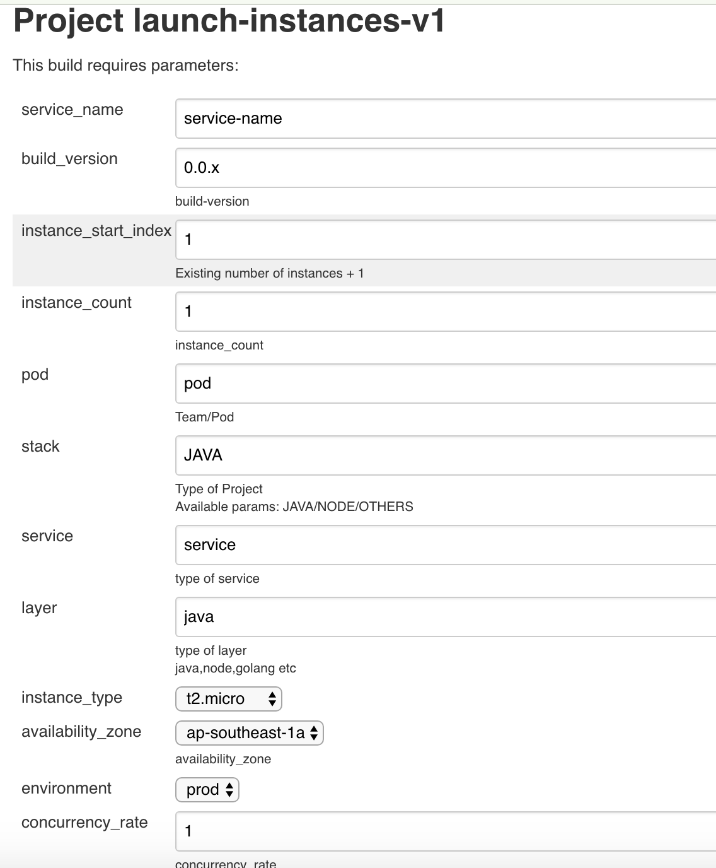

Deploy - Job for Service
Partial Deploy - http://jenkins.swiggy.co:8080/view/deploy/job/partial-deploy-v1/
We need the <service-name>, build version, and a host name for this. The code will be deployed on that host, and will be taken out of rotation in Kong.

Full Deploy - Once testing/sanity is done on the above host, go to http://jenkins.swiggy.co:8080/view/deploy/job/deploy-v1/ for full deployment.

Adding Service to Kong
When instances are launched, they are added as Upstream in Kong. Find your service under <service-name> here: http://kingkong.swiggyops.de/upstreams

Now, we need to add the service definition, routes, relevant plugins in Kong. Open http://kingkong.swiggyops.de/services - Click Add Service - Name is <service-name>, Host is Upstream Server name. Reduce the timeouts to a meaningful number, and save.
Next, we need to add Routes -
Plugins - Add prometheus.

Done.

SSH Access
If you need SSH access to boxes, use can use the job: http://jenkins.swiggy.co:8080/view/ssh-access/job/ssh-access/

To give you ssh access to any production box,
Click on “Build With Parameters” on left panel. And then provide the required list of comma separated machine names(e.g. ff-prod-fraud-detection-service-1.swiggy.prod,ff-prod-fraud-detection-service.swiggy.prod) and your ssh public key (~/.ssh/id_rsa.pub). Click on Build.

Common Use-cases
Listing down the high level steps for some common use-cases.

- Feature Release: Merge to master, Build, Deploy
- Change value of a config (eg. a timeout value) without any code change -> Change config value Consul, use: http://jenkins.swiggy.co:8080/view/restart/job/restart-config-v1/ to restart the apps to reflect the config.
- Reverting a release: Use prev. build version (which is stable), and then partial deploy/ full deploy.
- Rolling Restart a service (eg. possibly a memory leak etc. ) - Use http://jenkins.swiggy.co:8080/view/restart/job/restart-v1/
- What to do when you get this error: Another deployment is in progress in partial deploy job.
  - Need to abort the same with <servicename> used above and run this pipeline: http://jenkins.swiggy.co:8080/job/abort-deploy-v1/.

